**Before**

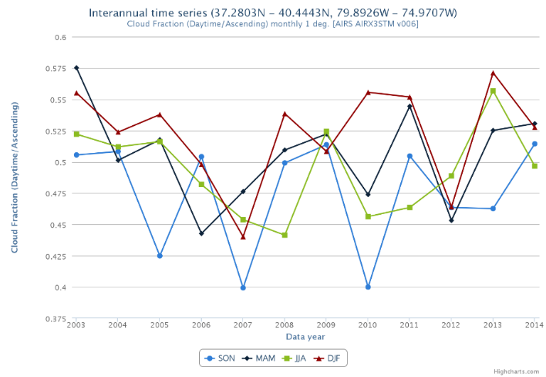

Source: <https://giovanni.gsfc.nasa.gov/giovanni/doc/UsersManualworkingdocument.docx.html>

The chart above is an example of too much information in one chart. Besides, lines and markers are not needed.

**After**

I simplified chart by splitting it to four separate charts. Every one of them have lines, vertical axis and horizontal lines removed. Instead I added horizontal gridlines for easier year reading and labels inside markers for easier values reading.

**Before**

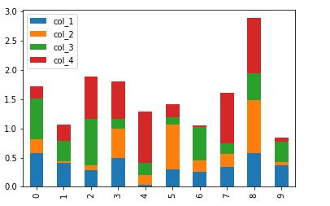

Source: <https://www.analyticsvidhya.com/blog/2021/07/how-to-perform-data-visualization-with-panda/>

This chart has one main problem. Colors. They are mostly non-readable for colorblind people. Not to mention that bars in that colors just look ugly.

**After  
**

I changed colors to one scale of blueish ones, added title, removed vertical axis, added labels (black ones on brighter colors and white ones on the darker blue). Labels on small values are hidden, they could be maybe added on the side with colored lines connected to bar segments. Legend unfortunately is needed here, but instead of adding default one, I entered text boxes with accordingly colored text.

**Before**   
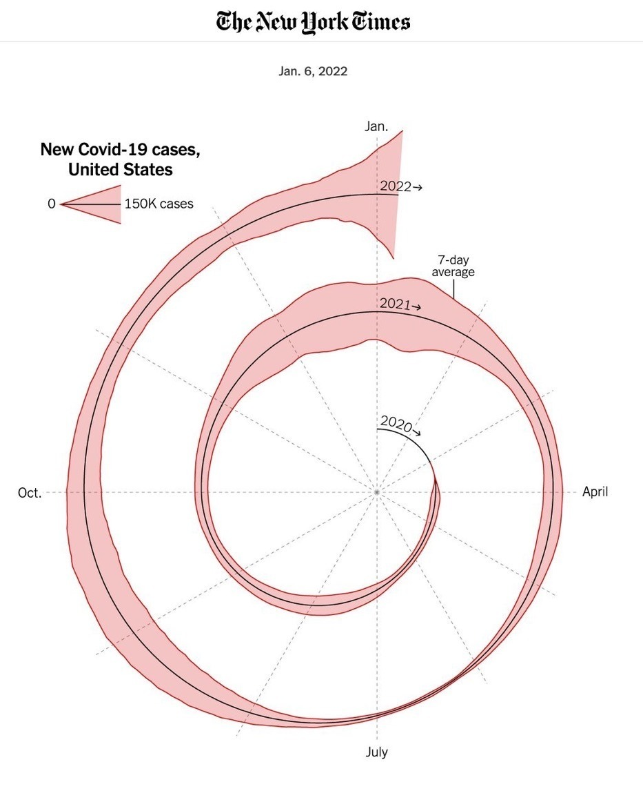

Source: <https://www.nytimes.com/2022/01/06/opinion/omicron-covid-us.html>

<https://github.com/nytimes/covid-19-data/blob/master/us-counties-2020.csv>

This is one of this weird charts made only to bring “why would someone ever do that” thought to you. Nothing here is readable besides months.

**After**

Even simplest chart made by default in Excel makes data much more readable. The area under the line is filled because my datasheet has several values for one day and sums it.

Website

Source: https://www.youtube.com

Site I chose is site that everyone knows about. Youtube is a service when anyone can upload a video and watch them. Because Youtube have millions of visitors every minute, their site follow modern standards for web design. Its simple, focuses on videos thumbnails, it has option for enabling light or night mode. Like standard modern websites, it only uses black/white colors, with accents of red, as their main logo color. It has search bar, with standard “on top of page” position, main content that you can scroll through, side content where you can choose what type of content you want to see, and several mini icons with different options attached to them. Overall its pretty simple but effective design, that even people with disabilities like color blindness could probably operate on with no problems.